R. Reports Menu: 4. Owner Labels

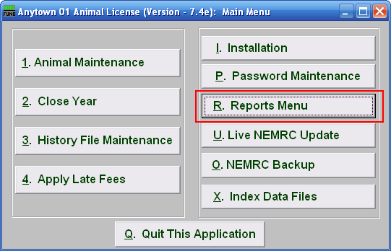
Click on “R. Reports Menu” from the Main Menu and the following window will appear:

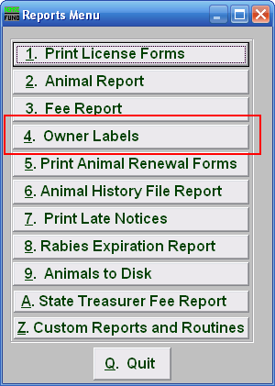
Click on “4. Owner Labels” from the Reports Menu and the following window will appear:

Owner Labels

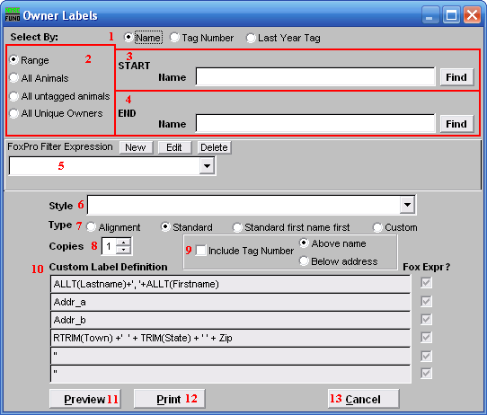
- Select By: Click to choose what the animals are listed by.

- Range OR All Animals OR All untagged animals OR All unique Owners: Click to choose a method of selecting animals to print labels for.

- Start: This is only available if you chose “Range.” Enter the tag number, or last year tag number, or Name, (depending on your choice in item 2) of the animal you wish to start with, or click “Find” and select from the Lookup table.

- End: This is only available if you chose “Range.” Enter the tag number, or last year tag number, or Name, (depending on your choice in item 2) of the animal you wish to end with, or click “Find” and select from the Lookup table.

- FoxPro Filter Expression: An optional conditional reporting expression developed with NEMRC support. This evaluates animal information to determine if the animal should be included. Contact NEMRC support to learn more about this option.

- Style: Click on the drop down arrow and choose the style of label that you want.

- Type: Select what type of label you want.

- Copies: Determine how many of each label you would like generated. This can be used for a mailing label, return address label and notice label in a three piece mailing.

- Include Tag Number: Click here to include each animal’s tag number in this report. You may choose to have it appear Above the name, or Below the address.

- Custom Label Definition: Call NEMRC for details on how to achieve what you are looking for on the labels.

- Preview: Click this button to preview. Refer to GENERAL PREVIEW for more information.

- Print: Click this button to print. Refer to GENERAL PRINTING for more information.

- Cancel: Click “Cancel” to cancel and return to the previous screen.

